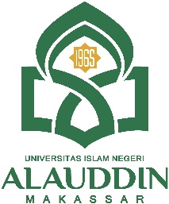
KEMENTERIAN AGAMA REPUBLIK INDONESIA
UNIVERSITAS ISLAM NEGERI ALAUDDIN MAKASSAR

FAKULTAS ADAB DAN HUMANIORA
Kampus I : Jl. Sultan Alauddin No.63 Makassar
Kampus II : Jl. H. M. Yasin Limpo No. 36 Romangpolong-Gowa Telp. (0411) 841879 Fax. (0411) 8221400
Email: fak.adabhumaniora@yahoo.com

Jl. Sultan Alauddin No. 63 Makassar Telp (0411) 864928 - 864931

LEMBAR PENILAIAN SEMINAR

NAMA : ZULFITRI HANDAYANI
JURUSAN : BAHASA DAN SASTRA INGGRIS
NIM : 40300114008
JUDUL SKRIPSI : PHATIC FUNCTION IN NICHOLAS SPARKS’S NOVEL “THE LONGEST RIDE”.
..............................................................................................................................
..............................................................................................................................
Metodologi | Isi | Cara Menyajikan | Jumlah | Rata-rata

Rekomendasi : ( ) Membuat Judul Baru (apabila nilai rata-rata di bawah 60)
( ) Mengulang seminar (apabila nilai rata-rata <70 )
( ) Lanjut penelitian dengan beberapa perbaikan (apabila nilai > 70)
Nilai :  A = 4 (85-100)  B = 3 (70-84)  C = 2 (60-69)  D = 1 (50-59)  E = 0 (0-49) | Romang Polong, Gowa, 07 September 2020  Konsultan 1  Dr. Hj. Nuri Emmiyati, M.Pd.  NIP. 19660212 200003 2 002

