Name : Rafika Nur Dzakira Ibrahim
NIM : 40300117081
Group : AG 4
Visiting Tribun Timur
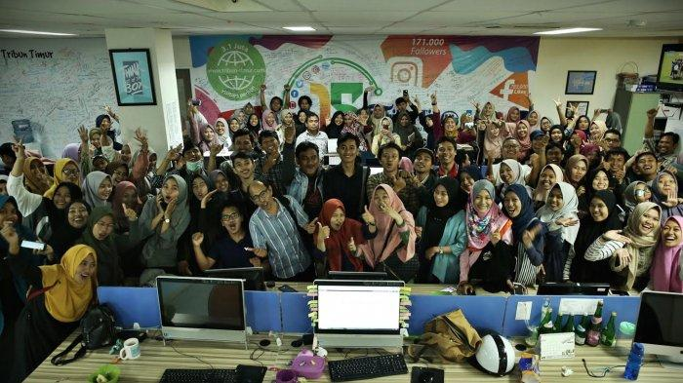
On Friday, 3rd May 2019, College student of English and Literature department, Adab and Humanities Faculty, Islamic State University of Alauddin Makassar has an agenda to visited the News Office Tribun Timur at Cendrawasih Street. This visit was followed by 120 college student of English and Literature department the fourth semester. There, the students was have sharing session and viisited the editorial staff office directly.
Mr. Taufik as the lecturer opened the sharing session. After that, Mr. Taufik invites the speaker from Tribun Timur, Uncle Ronald. He is a deputy chief editor of Tribun Timur. There are some important things that were conveyed by Uncle Ronald, one of that is the percentage of interest in reading a newspaper and the way of maintain the existence of the Tribun Timur, “average interest in reading newspapers around the world only reaches 6%, it means that people who read the newspaper very little. In dealing with that, Tribun Timur made innovation that making online newspapers, so that Tribun Timur can survive untill now”.
During sharing session, the students enjoyed it and they also take a video as evidences, 4 student gave their question and answered directly by the speaker. Then, the college student went to the Editorial staff office to see how to publish news into web. The students was very interesred with that and the end of the agenda was closed by taking photo together.

